**Bug Report**

|  |  |  |
| --- | --- | --- |
| ID number | #1 |  |
| Bug Summary | Fields can’t be longer than 10 characters |  |
| Reporter | Lusine Mesropyan |  |
| Submit Date | 08/02/2022 |  |
| Platform | Windows 10 Pro |  |
| Operating System | Windows 10 Pro 19041.450 |  |
| Browser | Chrome is up to date  Version 96.0.4664.110 (Official Build) (64-bit) |  |
| Severity | Major |  |
| Priority |  |  |
| Status | Open |  |
| Assigned to | QA/Developer/BA |  |
| Version | 1.0 |  |
| Environment | Testing environment  <http://qwallity4.herokuapp.com/exercises> |  |
| Component/tag | Program «Calculator» |  |
| Screenshot/video | Screenshot is shown under the page. |  |

**Description**: Field can not be more than 10 characters.

**Precondition**:

Go to the main <https://qwallity4.herokuapp.com/calculator> webpage

**Steps to reproduce:**

1.Open the main webpage

2.Go to the section “Exercises”.

3. Fill the fields more than 10 characters.

**Excepted result:** The “number1” and “number2” fields can’t fill more than characters.

**Actual result:** Fields “number1” and “number2” can fill more than 10 characters.

**Notes**: It is not calculating any result with more than 10 characters.

**References**:

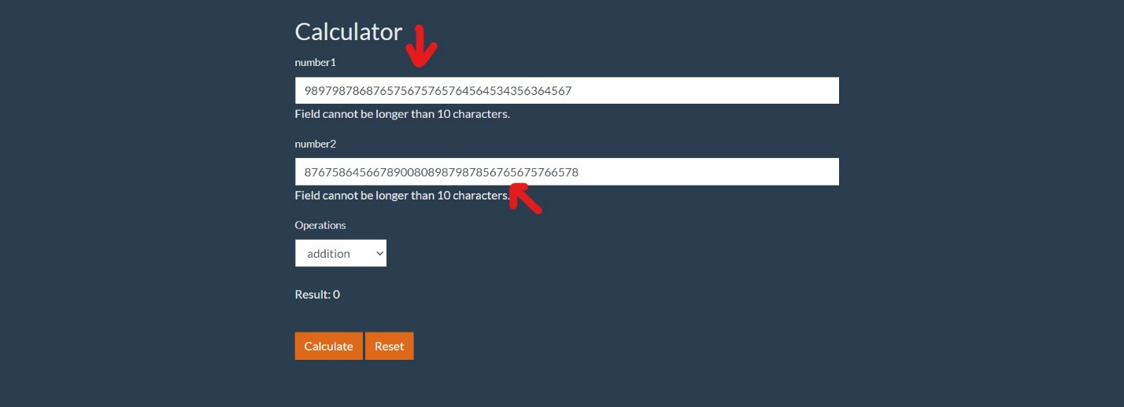

|  |  |  |
| --- | --- | --- |
| ID number | #2 |  |
| Bug Summary | After unsuccessfull login user can redirect to all pages with valid username besides "Home" page. |  |
| Reporter | Lusine Mesropyan |  |
| Submit Date | 08/02/2022 |  |
| Platform | Windows 10 Pro |  |
| Operating System | Windows 10 Pro 19041.450 |  |
| Browser | Chrome is up to date  Version 96.0.4664.110 (Official Build) (64-bit) |  |
| Severity | Blocking. |  |
| Priority |  |  |
| Status | Open |  |
| Assigned to | QA/Developer/BA |  |
| Version | 1.0 |  |
| Environment | Testing environment  <https://prod-qwallity.herokuapp.com/login> |  |
| Component/tag | Program «Qwallity » |  |
| Screenshot/video | Screenshot/video is shown under the page. |  |

**Description**

# After unsuccessfull login user can redirect to all pages with valid username besides "Home" page.

**Precondition:**

Go to the <https://prod-qwallity.herokuapp.com/login> webpage.

**Steps to reproduce:**

1. Open the main page.
2. Insert valid username and password.
3. Press “Log in”.
4. Shows Internal Server Error.
5. Click to go back.
6. Click on any page besides “Home” page.
7. Click on “Home” page.

**Expected result:** After login user can without hindrance enter any page of this app.

**Actual result:** After login user can redirect to any page with his valid username besides “Home” page.

**Severity:** Blocking.

References:

Some video

|  |  |  |
| --- | --- | --- |
| ID number | #3 |  |
| Bug Summary | **Password change execution gives error message.** |  |
| Reporter | Lusine Mesropyan |  |
| Submit Date | 09/02/2022 |  |
| Platform | Windows 10 Pro |  |
| Operating System | Windows 10 Pro 19041.450 |  |
| Browser | Chrome is up to date  Version 96.0.4664.110 (Official Build) (64-bit) |  |
| Severity | High |  |
| Priority |  |  |
| Status | Open |  |
| Assigned to | QA/Developer/BA |  |
| Version | 1.0 |  |
| Environment | Testing environment  <https://prod-qwallity.herokuapp.com/login> |  |
| Component/tag | Program «Qwallity » |  |
| Screenshot/video | Screenshot/video is shown under the page. |  |

## Description

**Password change execution gives error message.**

**Precondition**

Go to the <https://prod-qwallity.herokuapp.com/login> webpage

**Steps to reproduce**

1.Open the main webpage

2.Click to the "Login" section

3.Fill the "Username" with valid data

4.Fill the "Password" field empty or fill with invalid data

5.Click to the "Forgot Password" button.

6. Fill the Email field with the valid data.

7.Click to the "Send" button

**Expected result.** Must recognize the correct email. The process of changing the password must be successfully.

**Actual result**. Filling the Email field with the valid mail, and clicking to the "Send" button. There is a message showing . "Internal Server Error".

**Severity** High

References:

Some video

*Made by Lusine Mesropyan*